**TYPE:** Test

**TASK 9: Musculo-Skeletal System Test (73 marks)**

Students will complete a number of questions relating to the muscle and skeletal systems. These questions will address specific content as well as analysis of second hand data. This task will be completed in one session under test conditions.

**Time for the tasks (1 hour)**

* 5 minutes reading time
* 55 minutes working time

**What you need to do:**

* Follow the instructions provided very carefully to complete the test.
* Draw any results in pencil and answer all questions given.
* It is your responsibility to organise your time effectively.
* There is to be no discussion between you or any of your class mates.
* No sharing of any equipment or answers at all.

**DO NOT TURN THIS PAGE OVER UNTIL YOU ARE TOLD TO**

|  |  |  |  |
| --- | --- | --- | --- |
| PART | SECTION | Marks Available | Your Mark |
| A | Multiple Choice | 21 |  |
| B | Terminology | 10 |  |
| C | Short Answer | 26 |  |
| D | Extended response | 15 |  |
|  | TOTAL | 73 |  |

**STUDENT NAME: ____________________________________________________**

**TEACHER: Mrs Burns YEAR: 11**

**Musculo-Skeletal System Test**

**PART A: Multiple choice questions.**

**Please mark your answers in the answer section provided and NOT on the questions.**

1. A waste product of muscular contraction is
2. glycogen
3. lipase
4. lactic acid
5. carbonic acid

2. The joint between two vertebrae is an example of a

1. fixed joint
2. hinge joint
3. slightly moveable joint
4. pivot joint

3. In order to bend the arm at the elbow the biceps muscle must contract. At the same time the tricep muscle must

1. relax
2. shorten
3. push on the ulna
4. thin

4. Muscles which bend a limb at a joint are called

1. adductors
2. extensors
3. abductors
4. flexors

5. The joint illustrated below is a

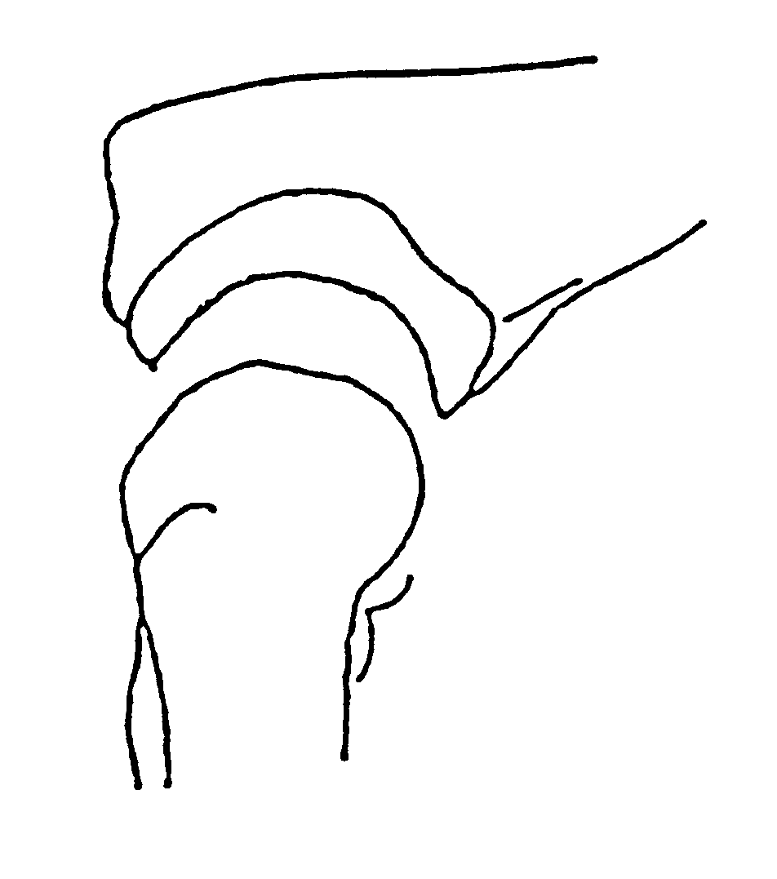

1. gliding joint
2. pivot joint
3. hinge joint
4. ball and socket joint

6. The shaft of a long bone is called the

1. periosteum
2. trabuculae
3. diaphysis
4. epithysis

7. The vertebral column, rib cage and skull form the

1. axial skeleton
2. appendicular skeleton
3. pectoral girdle
4. pelvic girdle

8. Five human vertebrae fused together form the

1. scapula
2. sternum
3. pelvis
4. sacrum

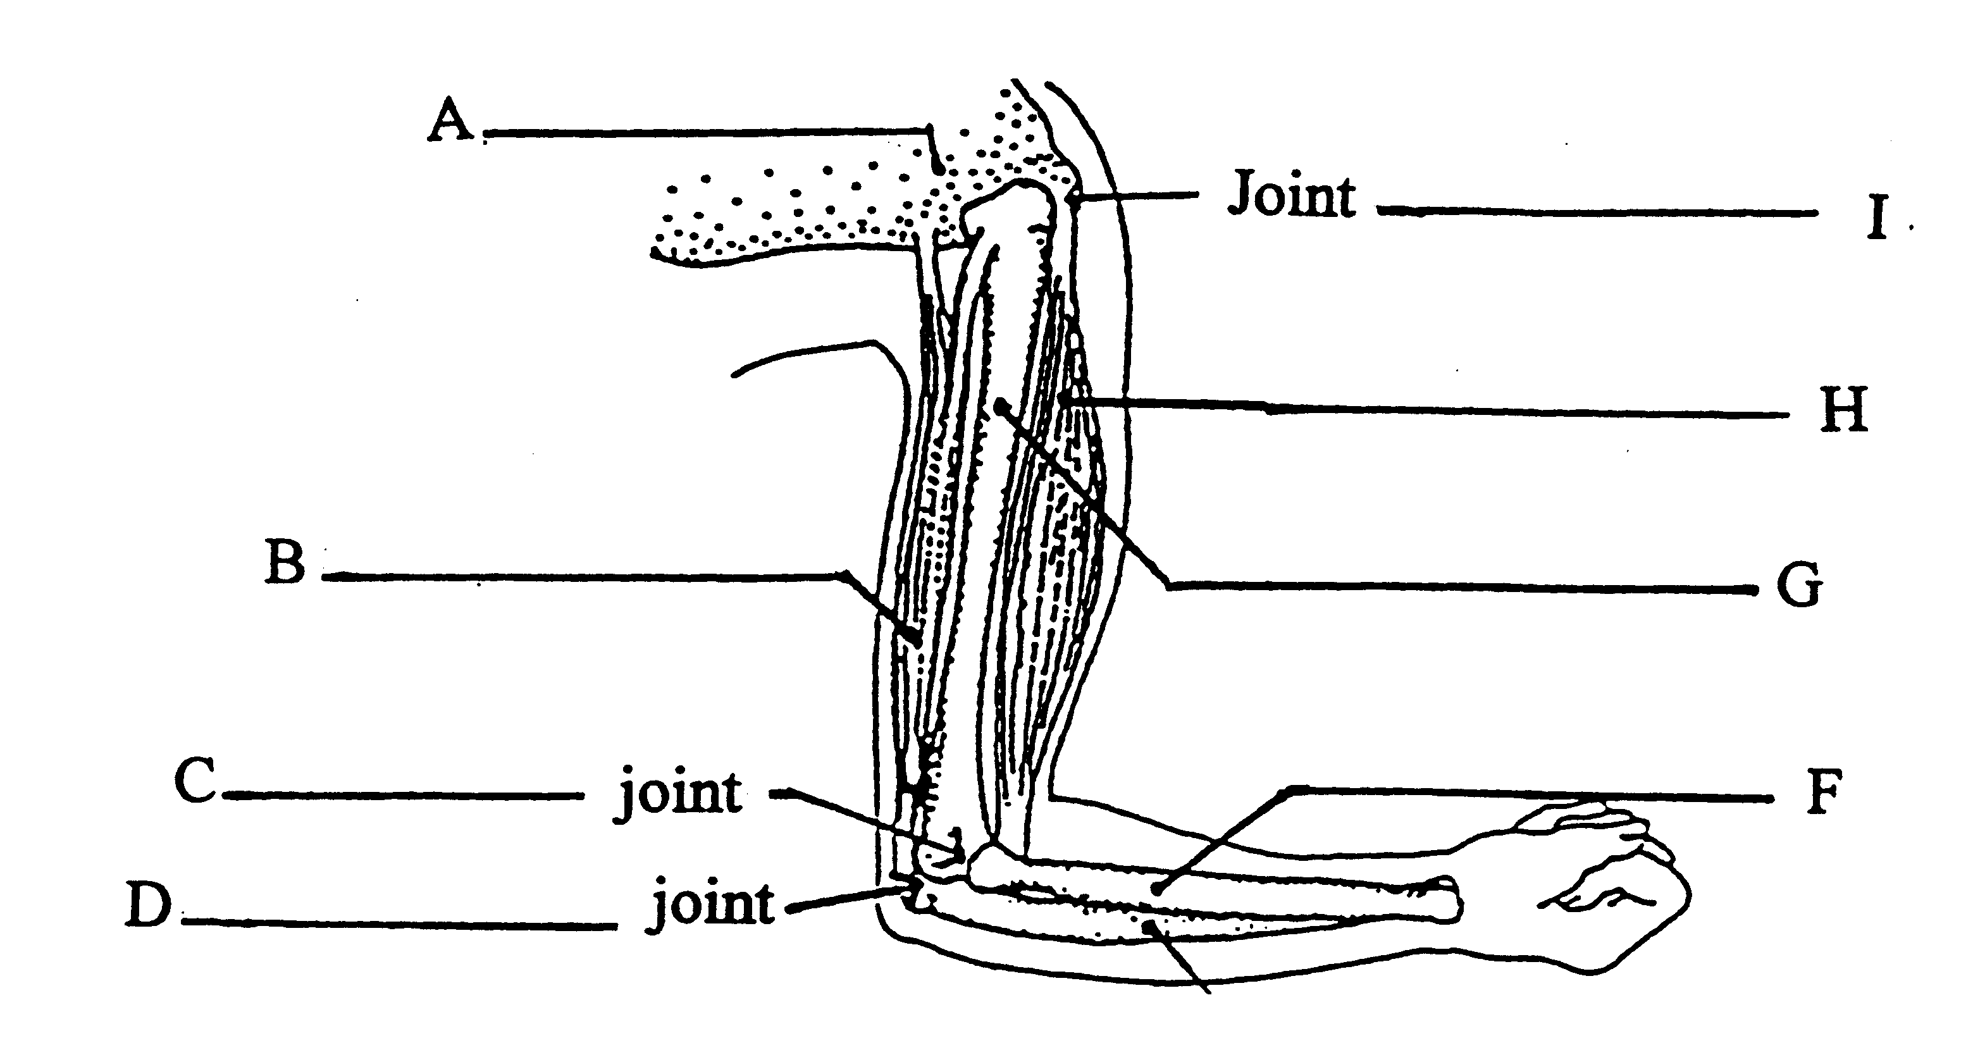

9. In the diagram above, the bone labelled F is the

1. radius
2. ulna
3. humerus
4. carpal

10. In the sliding filament model of muscle contraction which of the following occurs

1. the I bands lengthen
2. the actin filaments slide past the myosin filaments
3. the Z lines move further apart
4. the A band shortens

11 The opposability of the human thumb allows

1. the power grip to be utilised
2. the thumb to be well supported when moving it
3. the precision grip to be used
4. the thumb to bend and straighten

12 The fingers and toes are given the same name, that being the

1. metacarpals
2. tarsals
3. 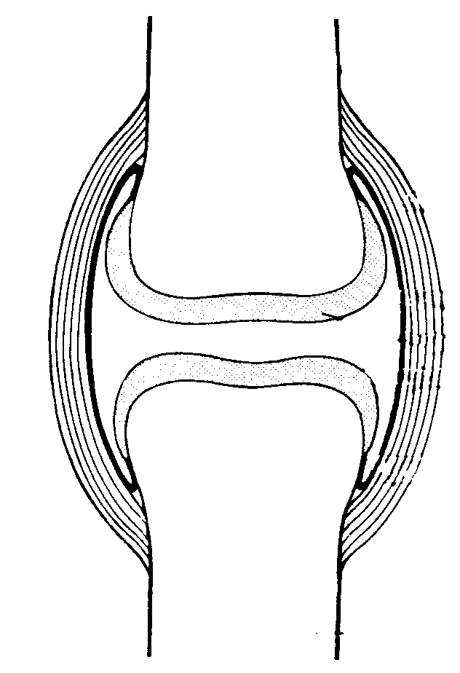metatarsals
4. phalanges

13 The type of joint illustrated above is a

1. pivot joint
2. ball and socket joint
3. synovial joint
4. articulated joint

14. Any movement away from the midline of the body is termed

1. rotation
2. abduction
3. flexion
4. adduction

.15. The shoulder blade is correctly termed the

1. sternum
2. sacrum
3. scapula
4. clavicle

16. The femur

(a) has one epiphysis and two diaphyses.

(b) is held directly onto the pelvic bone by tendons.

(c) articulates with the tibia and fibula at the knee.

(d) is angled toward the knee to produce a carrying angle.

17. The tibia and fibula would be flexed if the

(a) quadriceps relaxed and hamstrings contracted.

(b) quadriceps relaxed and hamstrings relaxed.

(c) quadriceps contracted and hamstrings contracted.

(d) quadriceps contracted and hamstrings relaxed.

18 In skeletal muscle contraction, the role of calcium ions is very important. The internal cellular structure that stores calcium is called the

(a) mitochondrion

(b) motor end plate

(c) microfilament

(d) sarcoplasmic reticulum

19. The range of movement permitted at a pivot joint includes

1. rotation
2. flexion and extension
3. abduction and adduction
4. circumduction

20. A student examining a slide of muscle tissue under the microscope saw the presence of striations and intercalated discs. The type of muscle he was looking at was

a. cardiac

b. skeletal

c. smooth

d. tendon

21. The movement of the arms shown in the diagram below is an example

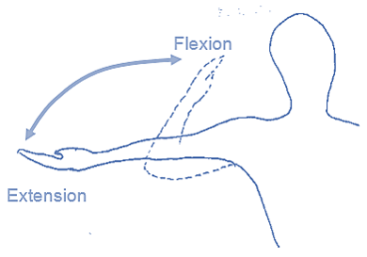

1. abduction and adduction
2. flexion and extension
3. rotation

(d) pivoting and gliding

**END OF MULTIPLE CHOICE QUESTION SECTION**

**PART B:** Terminology (10 marks)

Write the term, which best matches the meaning, in the space provided in the table below.

|  |  |  |
| --- | --- | --- |
| No. | Meaning | Term |
| 1 | The type of movement as exampled by lifting the arm upwards and away from the body. |  |
| 2 | The ability to do this distinguishes muscle tissue from all other tissue in the body |  |
| 3 | Maintaining partial contraction of skeletal muscles. |  |
| 4 | Thick myofilaments are composed mainly of the protein… |  |
| 5 | Little sacs of synovial fluid positioned in such a way as to prevent friction |  |
| 6 | The model which describes how muscles contract. |  |
| 7 | Cartilage which covers the surfaces of bones at a joint |  |
| 8 | Cartilaginous joints have this degree of movement. |  |
| 9 | The clavicle is part of this girdle. |  |
| 10 | A muscle is made up of bundles of these structures held together by connective tissue |  |

**PART C – Short Answer**

**Please write your answers in the spaces provided on this sheet.**

1. (a) Label the attachments marked A to F on the diagram below.

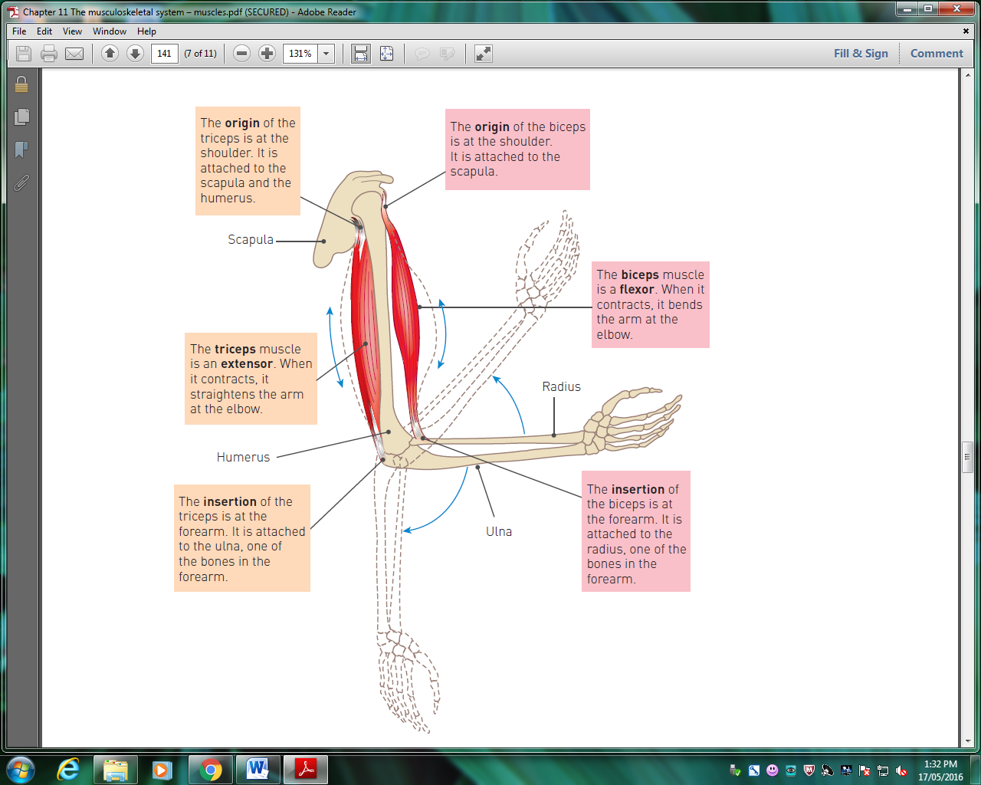

C

D

B

E

F

A

[6 Marks]

(b) B and E are antagonistic muscles. Explain how these two muscles work together to cause:

(i) flexion

____________________________________________________________________________________________________________________________________________________________________________________________________________________________________________________________________________________________________________

(ii) extension

____________________________________________________________________________________________________________________________________________________________________________________________________________________________________________________________________________________________________________

[4 Marks]

2. Joints can be classified according to the type of movement. Name the types of joints described below.

1. Joints which are immovable are called __________________________
2. Joints which are freely movable are called __________________________

[2 Marks]

3. Muscles possess the properties of extensibility and elasticity. Describe each property so the difference in meaning is clear.

________________________________________________________________________________________________________________________________________________________________________________________________________________________________________________________________________________________________________________________________________________________________________________________________________________________________________________________

[2 marks]

4. Draw a long bone. Label the following parts: diaphysis, epiphysis, marrow cavity, articular cartilages,

compact bone, spongy bone, bone marrow and periosteum.

[6 Marks]

5. Complete the following table.

|  |  |  |
| --- | --- | --- |
| **Type of synovial joint** | **Movement allowed** | **Locations** |
| Ball and socket |  |  |
| Hinge |  |  |
| Pivot |  |  |
| Gliding |  |  |
| Saddle |  |  |
| Condyloid |  |  |

[6 Marks]

PART D – Extended answer [15 marks]

Complete this question in the space provided below.

**Rule up an appropriate table** and describe the five main functions of the skeleton.

Give an example which illustrates each function.

END OF TEST